بسم الله الرحمن الرحيم



#### An-Najah National University

Faculty of Engineering & Information Technology

Computer Engineering Department

Software Graduation Project

The strategy game

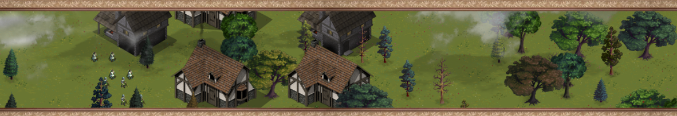Town Defenders

|  |  |
| --- | --- |
| Students: |  |
|  | Osama Abu Omar |
|  | Hakam Risheh |
|  |  |
| Supervisor: |  |
|  | Dr. Luai Malhis |

# Acknowledgments

**Osama Abu Omar, Hakam Risheh:**

We want to thank our project supervisor “Dr. Luai Malhis” and all the instructors who were a big part in making us the student graduate we are. And acquire the capabilities we expected to have the first time we got here, An-Najah Univ. And we also thank our parents for their support during the whole time of this project.

This page is intentionally left blank.

# Table of Figures

Figure 1 Sprite Examples 12

Figure 2 Sprite Sheet Sample, the Swordsman 13

Figure 3 the Title Screen 14

Figure 4 Menu Screen 14

Figure 5 New Game Settings 14

Figure 6 The Options Screen 14

Figure 7 Sample Gameplay Screen 14

Figure 8 Sample LinkLabel 14

Figure 9 The SwitchBox UI Control 14

Figure 10 Sample Tile Map with Tiles 14

Figure 11 Sample Building - Spanning Object 14

Figure 12 Sample Tree 14

Figure 13 Alignment of the Tiles on a Tile Map 14

Figure 14 Sample Cloud 14

Figure 15 Floating Cloud, Gameplay 14

Figure 16 Setting the Prominent Segment’s Depth 14

Figure 17 Building Selection 14

Figure 18 Multiple Selections 14

Figure 19 Double Click on a character to select same group 14

Figure 20 Unit avoids a tree 15

Figure 21 making a valid path 15

Figure 20 Unit avoids a tree 16

Figure 21 making a valid path 16

# Contents

بسم الله الرحمن الرحيم 1

1

Acknowledgments 2

Table of Figures 4

Contents 5

Abstract 7

Chapter 1: Introduction 8

Section 1.1: The .Net Framework 8

Section 1.2: XNA 4.0 Game Studio 9

Chapter 2: Constraints, Standards 11

Chapter 3: Literature Review 12

Section 3.1: Sprites 12

Section 3.2: Sprite sheets 12

Chapter 4: Methodology 14

Section 4.1: Beginning with the Game Screens 14

4.1.1: Game states 14

4.1.2: Building the game screens 15

4.1.3: The control manager 18

Section 4.2: Game Input 18

Input Mechanism 18

Section 4.3: Content management 19

Section 4.4: The Gamer Interface 19

Building Customized UI Controls 19

Section 4.5: Animating Sprites 20

4.5.1: Animation 20

4.5.2: Mobile Sprites 21

Section 4.6: The Tile Engine 21

4.6.1: Tile Engine 21

4.6.2: The Map Cell 21

4.6.3: The Tile Map 22

4.6.4: Objects that span multiple tiles 23

4.6.5: Implementing a 2D Camera 23

4.6.6: Drawing the map 24

Section 4.7: Cloud Effects 26

4.7.1: Clouds 26

4.7.2: The cloud manager 26

Section 4.8: Adding Audio 27

Music and sounds 27

Section 4.9: Game Basic Objects 28

4.9.1: The base Character type 28

4.9.2: The base building type 28

Section 4.10: Unit Selection 29

4.10.1: Selection theory 29

4.10.2: The ISelectable interface 31

4.10.3: The selection manager 32

Section 4.11: Moving Units 34

4.11.1: Unit movement theory 34

4.11.2: The IMovable interface 34

4.11.3: The movement manager 35

Section 4.12: Making Smart Paths 38

4.12.1: Path taking 38

4.12.2: Path finding algorithm 39

Chapter 5: Future Work 41

Section 5.1: Playing against the Computer 41

Section 5.2: The split screen viewing Mode 41

Section 5.3: Going mobile (a tablet version) 41

Chapter 6: Results and Analysis 42

Chapter 8: Conclusions and Recommendation 43

References 44

Books 44

Websites 44

Appendices 45

DISCLAIMER 45

A* Path Finding Algorithm Implementation 45

# Abstract

This game project lies under the strategic games type, it will initially be released for Windows PCs and Xbox 360 users and afterwards will be available for WP8 devices on the Windows 8 Market Place, for now, opponents can only play over a local area network.

We chose this project for several reasons; these type of games are becoming very popular these days and are able to attract a lot of players because Humans can play against each other (which is more fun than playing with a computer) and have some addiction to keep playing with a sense of achievement for what the game has to offer from building armies to conquer cities to maintaining the economical state. And it is easy to adapt in-app purchasing to make some profit as planned. Also this type of games is relatively less consuming to develop than most modern games. And in a personal manner, this project will be the entrance to professional game development.

The process of development will include initial Analysis (project requirements) and game prototyping (in a simple manner) to complete the general ideas and make some main decisions, then we’ll go through game graphical design (game world, characters, sounds …etc.), then comes the Design phase that will mainly focus on making a design that is easy to maintain and extend to make room for updates, and then we’ll start development and testing phases.

We’ll be using XNA 4.0 Framework for the game development process because it’s fairly less time consuming considering our previous experiences, and the best way to get into game development.

# Chapter 1: Introduction

## Section 1.1: The .Net Framework

.NET Framework (pronounced dot net) is a software framework developed by Microsoft that runs primarily on Microsoft Windows. It is open source and Microsoft with .NET 2015 is extending it to run on Mac OS platforms and Linux

.NET is an integral part of many applications running on Windows and provides common functionality for those applications to run. For developers, the .NET Framework provides a comprehensive and consistent programming model for building applications that have visually stunning user experiences and seamless and secure communication.

The .NET Framework is a technology that supports building and running the next generation of applications and XML Web services. The .NET Framework is designed to fulfill the following objectives:

* To provide a consistent object-oriented programming environment whether object code is stored and executed locally, executed locally but Internet-distributed, or executed remotely.
* To provide a code-execution environment that minimizes software deployment and versioning conflicts.
* To provide a code-execution environment that promotes safe execution of code, including code created by an unknown or semi-trusted third party.
* To provide a code-execution environment that eliminates the performance problems of scripted or interpreted environments.
* To make the developer experience consistent across widely varying types of applications, such as Windows-based applications and Web-based applications.
* To build all communication on industry standards to ensure that code based on the .NET Framework can integrate with any other code.

## Section 1.2: XNA 4.0 Game Studio

With the release of Windows 95, Microsoft also introduced the DirectX Application Programming Interface (API), which allowed Windows-based applications to integrate closely, in a standard way, with the graphics hardware available on the system. Prior to DirectX, most PC game development targeted MS-DOS, as Windows-based graphics were too slow for most gaming needs.

Although faster, working with the DirectX API could be challenging. The DirectX Software Development Kit (SDK) is targeted at C++, with no official support for other languages. The developer is also faced with large volumes of background work to get a DirectX project to the point where he can display images on the screen before ever considering the logic of the game itself.

In 2002, Microsoft released Managed DirectX as an interface to the API from its new .NET development environment. The .NET Framework consists of a set of code libraries to perform common programming tasks, and the Common Language Runtime (CLR) which allows code written in the various .NET languages (including Visual Basic .NET and C#) to be compiled into common runtime code. In order to support devices such as Windows Mobile phones, a subset of the .NET Framework was released, called the .NET Compact Framework. The .NET CF, as it is often abbreviated, removed non-essential components of the full Framework in the interest of saving storage space on handheld devices.

While Managed DirectX 2.0 was still in the beta phase, the project was cancelled, and Microsoft XNA was introduced in its place. XNA consists of the XNA Framework, a set of code libraries to perform common graphics, sound, and other game related tasks, and XNA Game Studio, an extension of the Visual Studio C# interface that includes a number of project templates to make use of the XNA Framework

The XNA project templates include an integrated game loop, easy to use (and fast) methods to display graphics, full support for 3D models, and simple access to multiple types of input devices.

In addition to Windows games, XNA allows deployment to both the Xbox 360, the Zune handheld media player (with XNA 3.1) and Windows Phone 7 Series phones (with XNA 4.0).

For the first time, a game console manufacturer has released a supported method for individual game developers to create (and sell!) content for their game console. Microsoft has even established the Xbox Indie Games system on Xbox Live to allow you to sell your creations to the world.

# Chapter 2: Constraints, Standards

We faced a lot of constraints at the beginning and during the project execution, this project needed more time and effort than what was applied, as also the artwork took a good amount of time relative to the available time, so in case of similar projects, there should be an artwork designer separated from the development work.

We had come to deploy a software development technique similar to the agile methodology, as we didn’t have to complete the design phase of the project to move on to segments of implementation and incremental deployment. Many of the software techniques were deployed in the development phase from a lot of software patterns and practices.

# Chapter 3: Literature Review

## Section 3.1: Sprites

In XNA a sprite is mainly a visible object on the screen, a scene is composed of multiple sprites.

A sprite itself is mainly composed of a 2d texture of part of a texture and a relative position.

Some sprites used in this game are static sprites but most of them are periodically changing sprite or animating sprites. So at this point and throughout the project we implemented a Sprite Animation class that handles drawing and moving sprites on the screen, also animating the sprite by looping through a sprite sheet texture that is previously created.

An example of normal sprites for 2D games is this graph taken from www.capcom-unity.com artworks. These are a refreshment character designs from the old indie game Street Fighter.

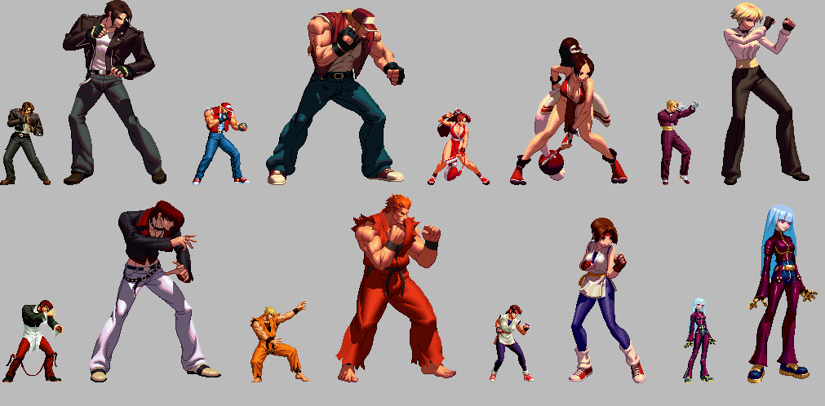

Figure 1 Sprite Examples

## Section 3.2: Sprite sheets

A sprite sheet is a large size texture image for a 2d game that contains a grid of the same image but animated in consecutive frames making a complete cycle of the sprite animation when played.

sprite sheets are better choice to load that loading all frames separated because at the time of the sprite sheet animation the graphics device keeps rendering frames pixels on the screen in a transitional way from one frame to the next and keeps looping on that, and so loading all the frames compound into one texture image file is a better choice for overall performance for it give a better spatial locality on frame pixel data.

Using the sprite animation class a sprite sheet can be used to play it's animation during game play, this gradually enhances the game experience and make it more realistic.

In this game art design, as an example of a sprite sheet, is the swordsman character.

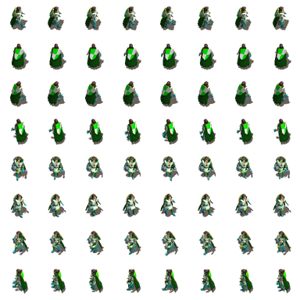

Figure 2 Sprite Sheet Sample, the Swordsman

# Chapter 4: Methodology

## Section 4.1: Beginning with the Game Screens

## 4.1.1: Game states

It is commonly obvious that in the process of developing any game in any framework is to start building the different game states that our game may have.

Most games usually have similar game states in a way that they do the same core functionality, like the start menu state and the game over state, all games have these or an extended versions with more customizations.

So in out game project's case we implemented initially the basic states of our game, which are:

* The title screen
* The start menu screen
* The options screen
* The new game settings screen
* And other screens need by their functionality

before starting the implementation we had a design thought on not just the basic state of a game but also the necessary behavior the happens on traversals between different states so we had to do a game stat manager that basically has a sacking logic of different states stacked by the order they were called or navigated to.

During the design and implementation throughout the project's timeline the game state manager had these capabilities:

As previously mentioned m the stack of states.

Updating and handling input from the current state only.

Viewing or drawing the sates depending on the stack order, this will enable partially transparent state to be viewed on top of other states, for example dialog boxes and such.

Navigation ability between states and on state change observers.

Composition of a control manager that manages and composes all the user interface controls that are added on the game state.

## 4.1.2: Building the game screens

After building all the needed controls and the control manager, and building the BaseGameState, at this stage the next step is to build every game screen by extending the BaseGameState and adding the required UI controls and visual designs on the UI screen.

The first screen is the Title Screen, it contains the title which is the name of the game and a starting button to move to the menu screen.

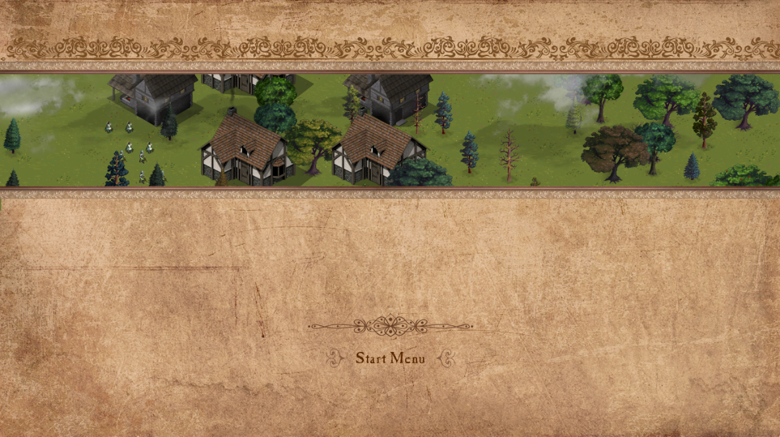

Figure 3 the Title Screen

The Menu screen, it contains a list of link labels, mainly options, start, exit, load, multiplayer screens,

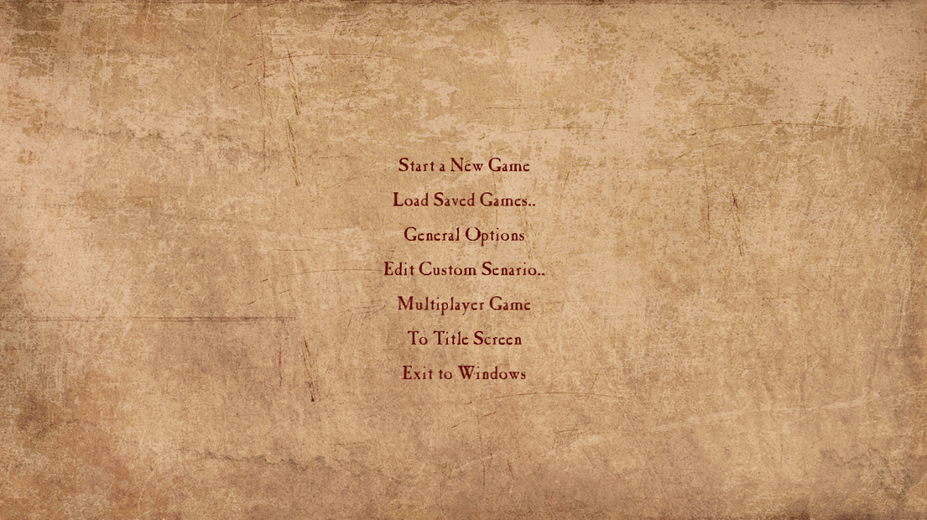

Figure 4 Menu Screen

The new game screen, where a new game session is generated, and the user has to put all the settings for the new game before starting, settings like the map size and the maximum population, and other setting like what is shown on the following screenshot.

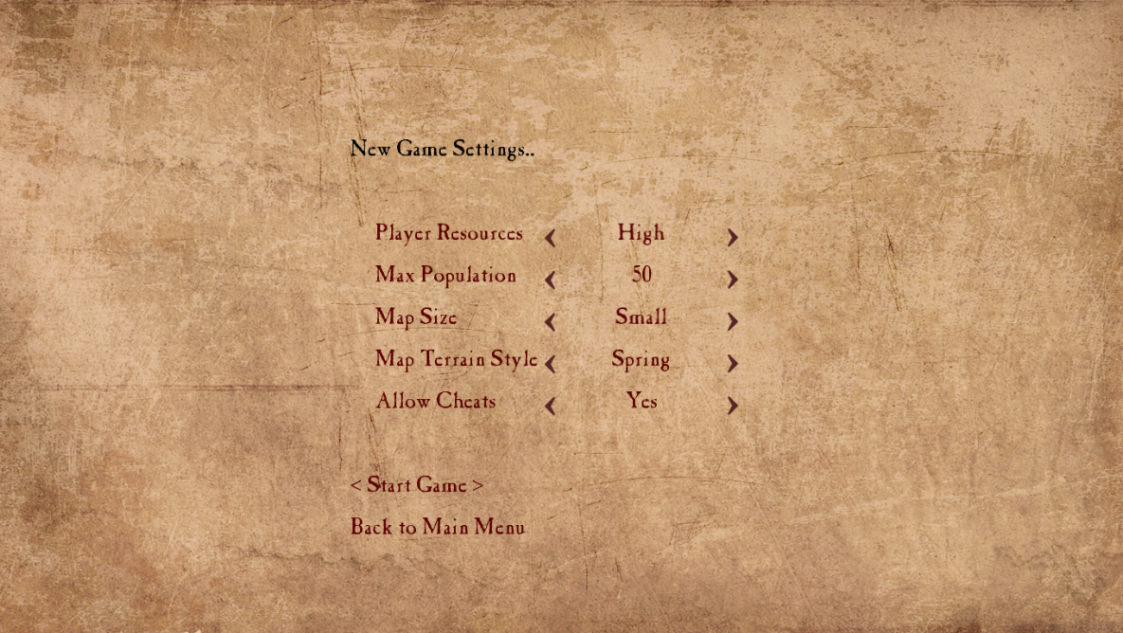

Figure 5 New Game Settings

The options screen where the user can decide to turn on or off background music and sound effects, also change the game resolution and the volume level, put the game to full screen mode or windowed mode.

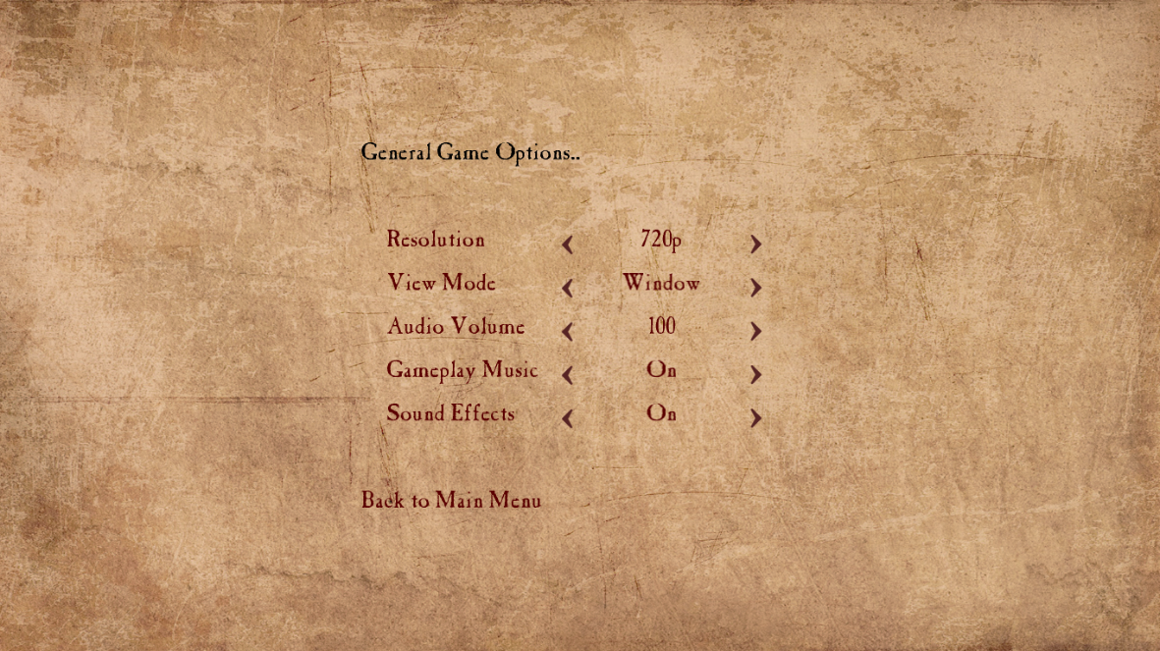

Figure 6 The Options Screen

The game play screen, where the whole actual game logic resides.

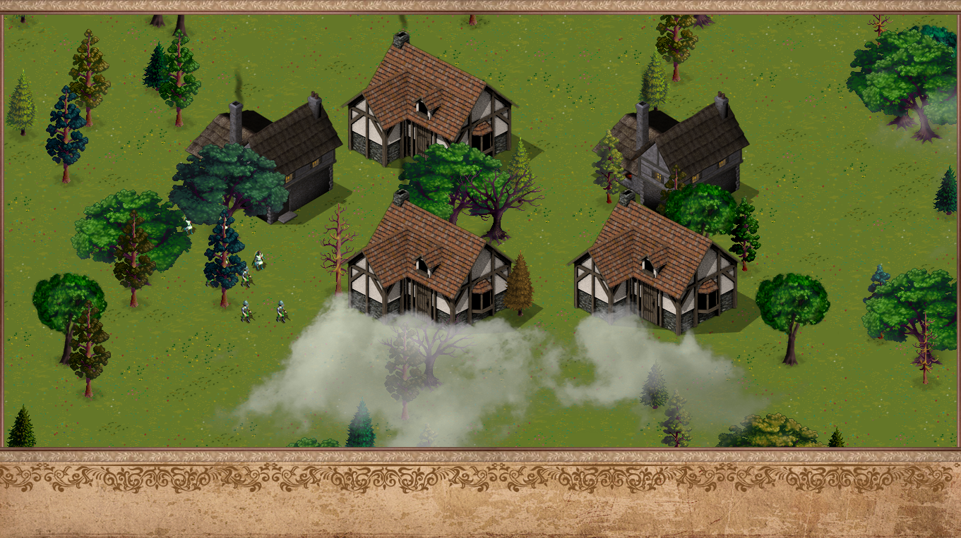

Figure 7 Sample Gameplay Screen

## 4.1.3: The control manager

Since all UI game screens have multiple controls on them, a control manager is created for every one of these screens to control and handle input from all the controls, no matter the type of the control, related to that screen, so, every screen composes a control manager object of their own, at the creation time of the game screen.

## Section 4.2: Game Input

## Input Mechanism

As the game should support input from mouse and keyboard and respond to mouse events like the selections and double clicking, we had to implement all event firing mechanisms by ourselves from scratch, so we created the Input manager class that makes it easier for the game to get invoked on multiple needed x`mouse and keyboard events, like hovering over an object, clicking and double clicking, entering and exiting an area…etc., as well as keyboard events like pressing a certain button, it may be pressed while holding functional keys, the class also handles pulling these input data and reading it every frame as this is the case in game development which is different than developing UI forms for example.

The game won’t be supporting input from gamepads as the natural game play is not possible for this kind of input, because the player will use a pointing device for most of the gameplay time.

## Section 4.3: Content management

Since a large number of different assets are deployed in this game, from textures and sheets to music files and sound effects, loader classes are created to handle loading all the required assets, and caching them into dictionaries for further use, this is a necessary optimization to save memory for future plans and enhances low capability devices to be able to play the game with the least memory capacity possible. In a forest map styled game, a lot of similar tree textures are drawn on the scene, but they all reserve the same texture on the main memory. That is the case for audio files and particularly sound effects.

## Section 4.4: The Gamer Interface

## Building Customized UI Controls

We had to develop our own UI controls to be deployed on the user interface screens of the game and during gameplay, so, we started incrementally developing one control by another as required, the first step is to build an abstraction of a control, since all controls must have a lot of common properties and events like mouse events, visibility, colors and captions and what so. So an abstract class called Control was developed at the beginning, this class was meant to be extended by other custom controls.

The first control is a PictureBox that encapsulates a portion of a texture image and its absolute location on the UI screen, later on the picture box had the capability to fade in and out for the indexer texture used to point to the on focus control.

The next control that we have built is the LinkLabel control, it’s basically a text that the user can click on and to do some kind of interaction. All UI screens having a list of these controls must register for the events these controls may fire.



Figure 8 Sample LinkLabel

Another needed control is similar to a normal ListBox or a ComboBox user control like in the Windows forms application or WPF applications. It should be mentioned that unfortunately, it turns out that it is a better solution to try and implement all the necessary controls by ourselves that searching for libraries because most of the libraries are either not customized enough for the game’s theme and the way of interaction wanted, though most of them are paid.

We came up with the SwitchBox control, as shown the next picture, the user can cycle multiple items by clicking the left and right arrows, or by clicking the caption, to select an item.



Figure 9 The SwitchBox UI Control

We also created a normal Label just to display some information on the screen, another needed control is an ImageButton, a square shaped button with an overlaying squared portion of an image and some textual info can be also overlaid on top of the button, this button is used in the dock bottom bar to create new buildings, workers, soldiers, or develop intel and do other actions.

## Section 4.5: Animating Sprites

## 4.5.1: Animation

Basically animations in this game are under two types of animations, sprite sheet animation of frame traversing and moving animation. We’ve used sprite sheet animations for characters moving and fighting visual states and mostly in miscellaneous objects like smoke rising from the building’s roof and for moving animations like clouds and moving all different characters. since the game executes by consecutive calls of Update and Draw in the long run, after all assets are loaded, the animation is done by changing the position state of the mobile animated sprite object and for the sprite sheet animations the next update call changes the frame index so that the next call of Draw bases on the next frame and so on that the character for instance appears to the player like it is animating in real time.

## 4.5.2: Mobile Sprites

The Mobile Sprite class encapsulates the sprite sheet animation and the movement animation in one single entity. It has basically a queue of relative positions on the map that the object can move throughout when travelling from different locations. The class also has properties for controlling the speed of movement, visibility, Target path and other optional settings.

## Section 4.6: The Tile Engine

## 4.6.1: Tile Engine

A major part of a role playing game is exploring the map of the world. This is a 2D role playing game and uses tiling. Tiling is the process of creating a larger image using many smaller images. Each of the smaller images is called a tile. Drawing the map is done using a tile engine. There are a few different types of tile engines, we will be using the most basic.

## 4.6.2: The Map Cell

We created a MapCell class that will represent one tile space on the map, the map cell object contains properties that are used in collision detection, which is one of the reasons on why to use a tile engine that it makes it easier and faster to detect for a collision of close objects.

Another important property is the DrawDepth, as the map itself is constructed from a two-dimensional array structure of map cells, and knowing that the map is isometric, it is obvious that the lower tiles are the ones that are closer to the screen so it is necessary to set the drawing depth for the lower tiles so that they appear closer to the screen and rendered later than the above tiles.

The main purpose of the tile engine is to limit the texture sizes of the large terrain and dynamically spatial located materials like grass, water, hills, dirt…etc. so, basically when we edit and build a map, we use many tiles from a tile set to construct larger objects.

To make all that possible, it is essential for the MapCell to compose those tiles. So we added three collections for the cell, which are: the Base tiles representing grass, and ground materials, the Height tiles, which are lifted tiles from the ground, like hills and mountains, these tile have a height figured from the number of height tiles, so that it makes any mobile object to lift as what should happen naturally. The third collection is the Topper tiles, just miscellaneous tile sized objects on the top of a tile, a bush for example.

Every map cell also has the ability to draw itself so that it makes it easier for the tile map to draw all the tiles by calling its Draw method.

## 4.6.3: The Tile Map

The tile map is composed of basically a matrix of map cell, it has a width and a height that determines the actual size of the map, most tiles are off screen, and so a map may be (and should be) much larger than the size of the screen. For an isometric view to be possible for all the map.

The following picture of a sample Isometric Tile Map was taken as a demonstration from reddit.com. the tiles on top are simply put together to form the whole map, and then another layer is used to put all the large objects like the tree in this graph.

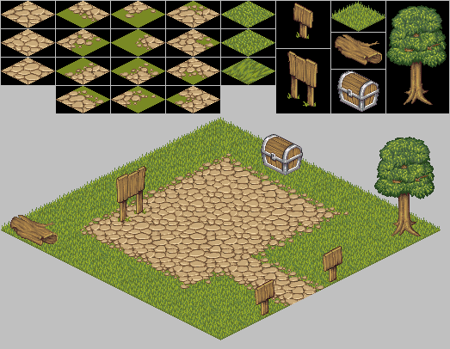

Figure 10 Sample Tile Map with Tiles

The tile map does a very important thing that it sets the locations of all the tiles to be attached together and appear as one piece of larger area, the next graph demonstrates that. Another thing is that the tile map object sets the depths of all its cells after doing some calculations depending on the tile’s location, so that all of the tiles are drawn properly at the appropriate depths. (The depths increase linearly from left to right and from top to bottom).

## 4.6.4: Objects that span multiple tiles

Many objects located in the game level’s map do span multiple tiles when drawn relatively on the map and rendered on the screen, like trees and most buildings and other miscellaneous objects. And as each tile at the same location is drawn with a different DrawDepth value, the problem relies on what depth to choose for the spanning large object to be able to draw it properly that it appears on top of all the beneath tiles and yet have the desired three dimensional behavior that is noticed when a mobile object walks around that object.

All the buildings and trees do span multiple tiles in the map, below are some samples.

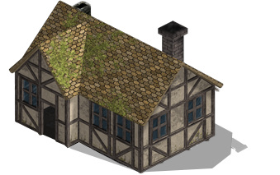

Figure 11 Sample Building - Spanning Object

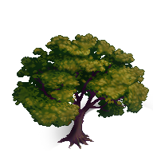

Figure 12 Sample Tree

## 4.6.5: Implementing a 2D Camera

The game player will be able to explore and view the world map using a 2D camera, because the world map size is beyond the size of the screen. The drawing code of all objects located on the map will use this camera as a reference to properly position the visual objects on the screen.

In order to do that, we had to write some helper methods that will convert map positions to actual positions related to the screen.

public static Vector2 WorldToScreen(Vector2 worldPosition)

{

return worldPosition - CameraLocation + DisplayOffset;

}

public static Vector2 ScreenToWorld(Vector2 screenPosition)

{

return screenPosition + CameraLocation - DisplayOffset;

}

The camera itself should be able to know the actual current dimensions of the viewing screen and get notified whenever the user changes the resolution of the game from the game options menu, the Camera class is much simpler in 2D games, in our it has a two dimensional vector property that refers to the current location of the camera, the location of the camera will change (the top left corner of the camera’s bounding rectangle), during gameplay the camera should respond to the arrow buttons and change location according to the direction of the arrow that is being held down, the Move method of the camera class will handle this.

## 4.6.6: Drawing the map

Drawing the map on the screen should depend first of all on the current location of the camera and on the width and height of the map itself, it’s already set that the camera cannot pan out of the map’s boundary. In the TileEngineInfo class, static constant values called the SquaresAcross and SquaresDown, for the default 720p resolution, they are set to the values 30 and 51 respectively, these values are chosen carefully so that the number of tiles that are actually drawn on this resolutions is 30 by 51 or 1530 tiles, so we only draw these tiles instead of drawing all the tiles on the map which is redundant since the tiles or even all objects that are located outside of the current camera’s boundary are not seen by the player.

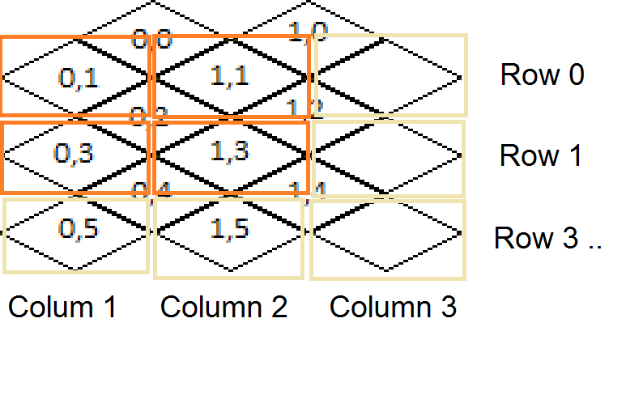

Figure 13 Alignment of the Tiles on a Tile Map

In the draw method of the tile map, we only loop through the tiles in the camera’s boundary and draw them with all the object on top of these tiles.

public void Draw(SpriteBatch spriteBatch)

{

var firstSquare = new Vector2(Camera.CameraLocation.X / TileInfo.TileStepX, Camera.CameraLocation.Y / TileInfo.TileStepY);

var firstX = (int)firstSquare.X;

var firstY = (int)firstSquare.Y;

for (var y = 0; y < TileEngineInfo.SquaresDown; y++)

{

for (var x = 0; x < TileEngineInfo.SquaresAcross; x++)

{

// polling x, y of map cell (depends on camera position)

var mapx = (firstX + x);

var mapy = (firstY + y);

MapCellAt(mapx, mapy).Draw(spriteBatch);

}

}

}

## Section 4.7: Cloud Effects

## 4.7.1: Clouds

We implemented clouds during game play as a nice effect to make the game even more realistic and fun, clouds simply float depending on wind direction and make a shadow on the ground, the clouds are transparent enough that they won't affect the sight, depending on the map style the number of clouds are set along with the direction.

A sample of a Cloud texture used in the game. A shadow of this cloud is shown in the gameplay.



Figure 14 Sample Cloud

## 4.7.2: The cloud manager

This Cloud Manager class takes control of the clouds from creation and movement of direction, when the number of clouds is set to N for example, the cloud manager keeps that number fixed so that clouds that disappear to the end location, to the far west for example, reappear again at the starting location, the starting location is always randomized and the speed of movement for each cloud is slightly diverse to move in a more natural form. The Cloud Manager keeps the textures and the set cloud objects the same as in not always when a cloud disappears generating another fresh one as this lowers the performance in longer game sessions and is considered bad practice.

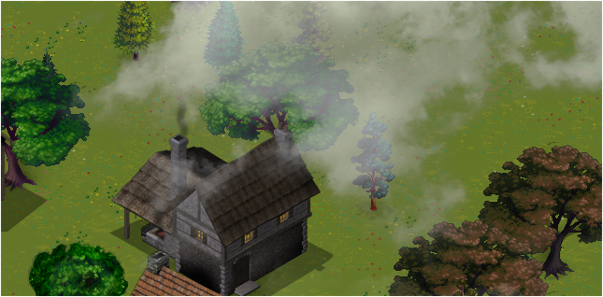

Figure 15 Floating Cloud, Gameplay

## Section 4.8: Adding Audio

## Music and sounds

As it is obvious that any game should have some kind of audio playback for more joyful game experience, this game will have music playback, a soundtrack that will play during game play and on start, also it will have many sound effects playing whenever some type of event happens, like for example, when selecting a building or when a soldier hits his sword in his attack mode, and many other cases, these type of effects will gradually improve the gameplay experience and make it more exiting and realistic.

The SoundManager class is responsible for loading, playing, and disposing two types of audio, long time soundtracks and sound effects. Sounds effects playing is treated in a different way, because multiple sound effects could play in a way they overlap when they are fired in very close times, that may happen when the player repeatedly presses some button with a sound effect.

## Section 4.9: Game Basic Objects

## 4.9.1: The base Character type

Public abstract class Character: GameObject ,ISelectable, IMovable

To start creating all the different character types in the game which are the farmer, swordsman, knight, archer, and builder…etc. as all these characters are similar in a lot of things from structural perspective and behavioral perspective, it is better to start building a base class type for all of these, the character class. The character in general can be selected and moved so the character class must implement the ISelectable and the IMovable interfaces as a beginning step. All characters have a visual representation, it is a sprite sheet containing all the animation state transition loops in all eight directions, this class is made to be extended as an abstraction of a character creature, hence, it could be an animal too.

## 4.9.2: The base building type

public abstract class Building: GameObject ,ISelectable

In the same manner as in the case of the character abstract class, for all the different types of buildings in the game, since all buildings have a lot of shared properties and behaviors, we also created the base Building class as an abstraction for any building in the game, this class type is meant to be extended, to create all the distinct buildings like for example the stable, the town center, and the residential houses.

Since all building must have the ability to be selected just like all the characters, the base building class must give an implementation for the ISelectable interface, and this is where we get benefit from making the ISelectable interface because we don’t have to implement a special mechanism for selecting all the buildings available in the game that is different in the character selection case.

Another thing that should be mentioned, since different buildings may be different in size compared to each other, or more specifically, buildings may occupy different number in tile map cells in high or width, two things must be implemented to all the extending child classes of the building class; first is to set the walkable properties for all the tiles that are occupied by the child building after setting the size of the building, another thing is to update the depths of the building texture segments in case those segments are prominent relative to other segments, the next graph will show an example of a prominent segment.

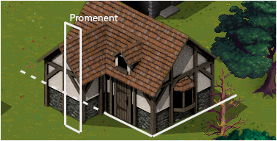

Figure 16 Setting the Prominent Segment’s Depth

An example of an extending class of the building class is the Residence and the Camp, the residence is a housing for the population whatever the type of the character, and the camp is like a building to train troops of soldiers in different kinds.

## Section 4.10: Unit Selection

## 4.10.1: Selection theory

At the design stage we needed some kind of user interaction with the units the player possess, so what is required is the ability for the user to select a unit using basically the mouse pointer at the moment, to let unit be ordered different commands that the unselected units can’t do.

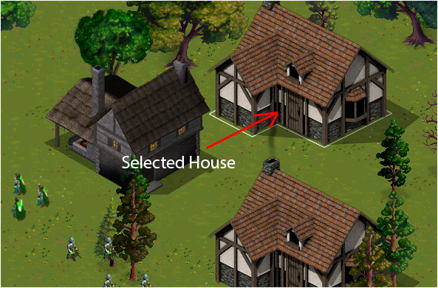

Figure 17 Building Selection

Another thing is that the player should have the ability to make multiple selections at a time, we referred to how Microsoft would handle the selection criteria as it is very familiar to the player, so we implemented multiple selection of the units under the same category by double clicking on one of these units, and multiple selections of units that lies on different categories! That is a unit at a time by simply holding the Ctrl key, using both double clicking and holding Ctrl key, the player can select groups at a time. This fastens the selection of the desired units no matter the diversity or the number of units.

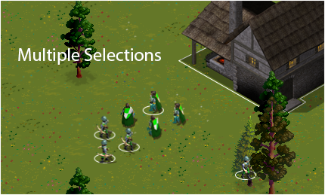

Figure 18 Multiple Selections

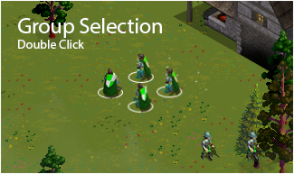

Figure 19 Double Click on a character to select same group

## 4.10.2: The ISelectable interface

Thinking about all the possible objects that may have the ability to be selected, these objects may be different in structure and behavior, so, it is much better to deploy one of the rules of software engineering, the interface segregation principle.

What we did is define an interface called ISelectable, and any kind of visible object that needs to have the selection ability would need to implement this interface.

The interface contains properties and methods that are needed for the entire selection process acquires all the needed information. Implementing classes may handle selection in their own way, for example when a human character is selected, a sound effect may be fired, a bounding circle appears around the character, where a building when selected, it will change what is viewed on the bottom dock bar, and show other buttons related to the same building.

public interface ISelectable

{

int SelectionGroup { get; set; }

void Select();

void DeSelect();

bool IsSelected { get; set; }

Rectangle SelectBounds { get; }

int Id { get; } // implemented by the GameObject

}

## 4.10.3: The selection manager

This manager uses the ISelectable interface to manage all the selection events no matter the type of object as long as they are selectable objects already.

The UnitSelectionManager class has a very important method called ManageSelection, this method is called by all the Selectable objects in their respective Update stages, and this is where the complex code resides.

public void ManageSelection(ISelectable unit)

{

/// the calling object should know if there was even a mouse or any other input happened

/// in this frame or not.

if (_selectionEventHappened) // **TODO and with if click position is within bounds of camera**

{

/// this item is from now considered as managed

/// the calling object may be needed if a double click occured

/// if DC occured, then all previosly managed Selectable objects (stored inside currentFrameManagedItems list)

/// in the same category as this one (the DClicked one) must be also selected

/// (we don't need the currentFrameManagedItems list after that a DC happened)

_currentFrameManagedItems.Add(unit);

/// the calling selectable item is the item that was clicked on

if (ItemClickedOn(unit))

{

/// this flag is used to say: well, ok, this selectable object is clicked on. so now i am sure that

/// the user didn't click on an empty area. (continuos in the update method)

_nothingIsCurrentlySelected = false;

#region MouseLeftButtonClicked

if (_mouseLeftButtonClicked)

{

if (_ctrlDown)

{

flipSelectionState(unit);

if (unit.IsSelected) // became selected

CurrentlySelectesItems.Add(unit);

else

RemoveItemFromSelectedObjects(unit);

}

else

{

CurrentlySelectedGroups.Clear();

if (!unit.IsSelected)

{

DeSelectAll();

selectItem(unit);

CurrentlySelectesItems.Add(unit);

}

else if (unit.IsSelected)

{

DeSelectAllExept(unit);

}

}

}

#endregion

#region MouseLeftButtonDoubleClicked

if (_mouseLeftButtonDoubleClicked)

{

if (_ctrlDown)

{

CurrentlySelectedGroups.Add(unit.SelectionGroup);

// select all items in currentFrameManagedItems list

foreach (var item in _currentFrameManagedItems)

{

if (item.SelectionGroup == unit.SelectionGroup)

{

selectItem(item);

CurrentlySelectesItems.Add(item);

}

}

_currentFrameManagedItems.Clear();

}

else

{

DeSelectAll();

CurrentlySelectedGroups.Clear();

CurrentlySelectedGroups.Add(unit.SelectionGroup);

// select all items in currentFrameManagedItems list

foreach (var item in _currentFrameManagedItems)

{

if (item.SelectionGroup == unit.SelectionGroup)

{

selectItem(item);

CurrentlySelectesItems.Add(item);

}

}

_currentFrameManagedItems.Clear();

}

}

#endregion

}

if (IsWithinSelectedGroups(unit))

{

/// in the same frame update, a unit is DC on (multiple selection with same group number)

/// if this selectable lies under the same group, then automatically select it

if (!unit.IsSelected)

{

selectItem(unit);

CurrentlySelectesItems.Add(unit);

}

}

}

}

## Section 4.11: Moving Units

## 4.11.1: Unit movement theory

Almost all living units from human soldiers and workers, all animals and war machines must have the ability to move from one location to another in a smart sense. The path taken by any of these units is very simple in its own structure, it contains a queue collection of path stop points implemented as points or two dimensional vectors representing map referenced locations. A moving unit will move in straight lines through all the path segments until the destination is reached, we already developed a PathFinder class that has a method called FindPath that returns a collection of points needed to be taken by the moving thing. These points’ outtakes the points that violate the idea that the object moves without colliding unnaturally with other block objects.

Moving units can be ordered to move at any time if they are already selected where the paths are fetched at that time. So we must be careful to make this process as optimized as possible in case the player may have the option to raise population up to 500 for each opponent.

## 4.11.2: The IMovable interface

Similar to what we’ve done in the design and development of the selection mechanism, the IMovable interface is defined and implemented by all the visual objects that may have the capability to move in a smart way from point to point.

public interface IMovable

{

float Speed{ get; set; }

Vector2 MoveDirection{ get; set; }

Vector2 Distination { get; set; }

Vector2 PreviousMoveDirection { get; set; }

bool CanGetMoveOrder { get; }

Vector2 CellLocation { get; }

Vector2 Position { get; set; }

int CurrentPathSegment { get; set; }

List<Vector2> MovingPath { get; set; }

Vector2 DrawOffset { get; }

bool IsMoving { get; }

void UpdateMovingAnimation();

bool MoveDirectionChanged();

void MoveBy(float X, float Y);

void Stop();

}

The interface defines methods for updating the visual state of the moving object. The unit currently moving in our game have the ability to move in 8 directions N, W, S, E, NW, NE, SW and SE. so when moving through path segments the visual state is allowed to be changed and make the character for example look to the east when it walks towards the east. This is handles in the character class that implements the IMovable interface.

## 4.11.3: The movement manager

The UnitMovementManager class has an important method, the ManageMovement method, all moving objects call this in their update stages, this method takes care of moving all the currently moving objects to the next point in the current path segment, and to the following segment until the path is complete and the unit stops moving.

public void ManageMovement(IMovable movable)

{

movable.PreviousMoveDirection = movable.MoveDirection;

// new move-to command

if (movable.CanGetMoveOrder && _mouseRightButtonClicked)

{

var rightClickLocation = GetMouseCellLocation();

var path = PathFinder.FindPath( movable.CellLocation, rightClickLocation, _worldRef.Map );

movable.MovingPath = path;

if (path != null && path.Count > 1)

{

movable.CurrentPathSegment = 1;

// initially move to first segment..

SetMovableToMoveToCell(movable, movable.MovingPath[movable.CurrentPathSegment]);

}

}

// update already moving objects in this frame

if (movable.IsMoving)

{

if (MovableReachedCurrentDistination(movable))

{

if (++movable.CurrentPathSegment == movable.MovingPath.Count)

{

// here movable reached its final distination

movable.Stop();

Console.WriteLine("distination location reached");

}

else

{

SetMovableToMoveToCell(movable, movable.MovingPath[movable.CurrentPathSegment]);

}

}

#region obselete code

//if (mapRef.GetCellAtWorldPoint(Visual.Position + currentMoveDir * CharSpeed).Walkable == false)

//{

// currentMoveDir = Vector2.Zero;

//}

//if (Math.Abs(mapRef.GetOverallHeight(Visual.Position) - mapRef.GetOverallHeight(Visual.Position + currentMoveDir * CharSpeed)) > 10)

//{

// currentMoveDir = Vector2.Zero;

//}

#endregion

if (movable.MoveDirectionChanged())

{

movable.UpdateMovingAnimation();

}

movable.MoveBy(movable.MoveDirection.X * movable.Speed, movable.MoveDirection.Y * movable.Speed);

#region Clamping

float visualX = MathHelper.Clamp(

movable.Position.X, 100 + movable.DrawOffset.X, Camera.WorldWidth - 100); //**TODO 100 only for debugging**

float visualY = MathHelper.Clamp(

movable.Position.Y, 100 + movable.DrawOffset.Y, Camera.WorldHeight - 100);

movable.Position = new Vector2(visualX, visualY);

#endregion

#region Camera Follows the Character

// Camera follows the character if he comes closer to any of the edges of the screen by 100 pixels.

Vector2 testPosition = Camera.WorldToScreen(movable.Position);

if (testPosition.X < 100)

{

Camera.Move(new Vector2(testPosition.X - 100, 0));

}

if (testPosition.X > (Camera.ViewWidth - 100))

{

Camera.Move(new Vector2(testPosition.X - (Camera.ViewWidth - 100), 0));

}

if (testPosition.Y < 100)

{

Camera.Move(new Vector2(0, testPosition.Y - 100));

}

if (testPosition.Y > (Camera.ViewHeight - 100))

{

Camera.Move(new Vector2(0, testPosition.Y - (Camera.ViewHeight - 100)));

}

#endregion

}

}

## Section 4.12: Making Smart Paths

## 4.12.1: Path taking

Almost all characters and in general intelligent creatures and objects in the game move through a smart path that is not to collide with walls and trees and other collide able objects, so it is natural the when that object is given the order to move from one point location to a destination location that the moving path is not a single straight line but is segmented to multiple vectors or path segments the character will move through in order not to collide with anything on the way, and this requires generally from the first glance of thought a path finding algorithm.

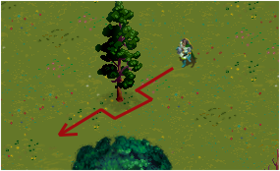

Figure 20 Unit avoids a tree

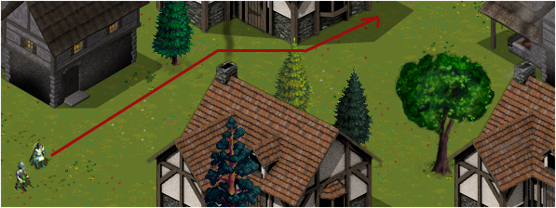

Figure 21 making a valid path

Referring to what we learned from the Artificial intelligence course, there are many path finding algorithms out there, each one has its own cons and pros, so we had to choose one suitable algorithm.

A simple Depth first search of Breadth first search algorithm will do the work theoretically, but when the tile map is in our case larger than 100 width by 100 height for example , and assuming 10% of the tiles are not walkable ( as it is much larger than that ). Then using any of these two algorithms will require building a huge tree of tiles ( or needed logical representation of a tile) that is 90% Times 100 width times 100 height or 9000 tree nodes as a worst case scenario in order to find the goal tile destination. It is not practical to have the need to build this tree for every object given the command to move considering that multiple objects can be ordered to move at the same user perspective time, so a fetch for a path is constructed at the same time, this game supports multiple selections and movement up to 20 units at a time.

Another problem noticed that when the units are very far from the destination location and at maximum number of units, it is costly that it takes a long time fetching for paths that the game may have a risk of dropping some frames at the time the update is executed knowing that the game must support 60 frames per second, especially when the same update logic for that frame need another processing time for other logic in the future.

Another option is the A* algorithm, which is a far better solution and much more optimized for our case because it takes advantage of the idea that we’re fetching a path on a spatial area we’re other factors can be put to use, this is implemented in a hysteric function that calculates the linear distance from the current location to the destination location.

We chose and implemented A* over the others because the tree structure grows towards the destination tile and the average tree structure is much less in size than the case of DFS or BFS, therefore making it best in terms of memory cost and processing speed in the scale of game frames.

## 4.12.2: Path finding algorithm

The tile map the game map is constructed from has a matrix of tiles that have many useful properties that the path finder class will get benefit from, the most important property used is the walkable property, basically a walkable tile is a tile that a moving character or a ground based object can walk through, and an none-walkable tile is a movement blocking tile for these objects.

So, we need to implement the path finding algorithm to use that property.

To illustrate this, let’s assume that the large spanning object is a building, the natural behavior for a character roaming around the building is of course, not to go through the building, this is easily implemented by making the ground of the building none-walkable at the build time, another behavior, another thing is that when the character walks behind the building ,considering the custom building structure, the building should be on top of it giving the illusion of three definitional effect of the building. Other behaviors may be required during the project’s timeline.

After taking some time to analyze the problem and studying what is basically required, we came up with one possible solution that is to divide the large spanning object’s visual state to multiple segments with each segment having the width of half a tile, then making the bottom middle tile as a reference tile, expanding from the middle to both directions and giving each segment the width of the tile it lies on top. This way it will give the required behavior at the moment.

# 

# Chapter 5: Future Work

## Section 5.1: Playing against the Computer

The future edition will enable the player to choose to play against computer controlled players, a complex AI system will have to be developed, but it will be a better choice for the player to play against his computer instead of not playing at all in case no human plyers exist.

## Section 5.2: The split screen viewing Mode

Most strategic games, where the map is much bigger than the viewing screen itself, have the same annoying problem that when the player has to split his army for example and send them to different places, it gets harder to keep tracking both teams by moving the camera back and forth to keep an observation on both teams, so creating a split screen, or in other words, two cameras for the same game, and controlling both cameras with different keys, enables the player to view distant units on the same screen at the same time.

## Section 5.3: Going mobile (a tablet version)

Even if the idea seems hard to drop the mouse control, since these games are a lot easier using a pointer device, the mouse, and considering that it’s always a god idea to make a version for tablet devices (not smart phones) for the same game but with a redesigned input mechanism to support touch input, meaning that different players can still play in multiplayer mode with one using a PC and another using a Tablet. It would be great to do this kind of feature.

This is technically possible using the MonoGame solution, this game can be migrated to Android and iOS devices, but the process needs an additional development time.

# Chapter 6: Results and Analysis

From the first insights, even when the game is not complete at the final desirable form, the human interaction is fairly good as well as the map navigation and visual appearances from textures and backgrounds, many viewers actually liked the game after it’s showed in the discussion day of the project. After the game is released, it will be joyful to play as expected.

# Chapter 8: Conclusions and Recommendation

As we’ve reached a viewable state of the game, it is quite promising and fun to play which is the purpose put for this project, entertainment is the major goal and measuring reference.

We could improve the performance of the work by effectively put a time measure for every phase and deploying an art worker or designer for all the artwork needed.

One of the main reasons for picking this kind of project is to enter the game development world the by making initial steps and using this framework, so now we have quite good experience of how game development differs from what we’ve used to in developing many projects before.

# References

## Books

C# 5.0 Programmer's Reference - Stephens, Rod

O Reilly C Sharp 5.0 in a Nutshell 5th Edition Jun 2012

XNA 4.0 Game Development by Example

Advanced C Sharp Programming – Paul Kimmel

## Websites

<http://msdn.microsoft.com/en-us/library/zw4w595w.aspx> - .NET Framework

<http://www.opengameart.org/> - 2D art, Isometric

<http://www.freesfx.co.uk/> - Sound effects

<http://msdn.microsoft.com/en-us/library/bb203893.aspx> - XNA 4.0

<http://www.riemers.net/> - Riemers XNA Tutorials

<http://www.xnaresources.com>

# Appendices

## DISCLAIMER

This report was written by Osama N. Abu-Omar and Hakam Risheh at the Computer Engineering Department, Faculty of Engineering, An-Najah National University. It has not been altered or corrected, other than editorial corrections, as a result of assessment and it may contain language as well as content errors. The views expressed in it together with any outcomes and recommendations are solely those of the student(s). An-Najah National University accepts no responsibility or liability for the consequences of this report being used for a purpose other than the purpose for which it was commissioned.

## A* Path Finding Algorithm Implementation

The path node class

public class PathNode

{

public PathNode ParentNode;

public PathNode EndNode;

private Vector2 _gridLocation;

private readonly Vector2 _cellCenterPosition;

public float TotalCost;

public float DirectCost;

public Vector2 GridLocation

{

get { return _gridLocation; }

set

{

_gridLocation = value;

}

}

public int GridX

{

get { return (int)_gridLocation.X; }

}

public int GridY

{

get { return (int)_gridLocation.Y; }

}

public PathNode(

PathNode parentNode,

PathNode endNode,

Vector2 gridLocation,

Vector2 cellCenterPosition,

float cost)

{

_cellCenterPosition = cellCenterPosition;

ParentNode = parentNode;

GridLocation = gridLocation;

EndNode = endNode; DirectCost = cost;

if (endNode != null)

{

TotalCost = DirectCost + LinearCost();

}

}

public float LinearCost()

{

return (Vector2.Distance( EndNode._cellCenterPosition, _cellCenterPosition ));

}

public bool IsEqualToNode(PathNode node)

{

return (GridLocation == node.GridLocation);

}

}

The PathFinder Class has the main method FindPath()

static public List<Vector2> FindPath(Vector2 startTile, Vector2 endTile, TileMap mapRef)

{

if (!mapRef.MapCellAt(startTile).Walkable || !mapRef.MapCellAt(endTile).Walkable)

{

return null;

}

OpenList.Clear();

NodeCosts.Clear();

nodeStatus.Clear();

var endNode = new PathNode(null, null, endTile, mapRef.MapCellAt(endTile).CenterPosition, 0);

var startNode = new PathNode(null, endNode, startTile, mapRef.MapCellAt(startTile).CenterPosition, 0);

AddNodeToOpenList(startNode);

while (OpenList.Count > 0)

{

var currentNode = OpenList[OpenList.Count - 1];

if (currentNode.IsEqualToNode(endNode))

{

var bestPath = new List<Vector2>();

while (currentNode != null)

{

bestPath.Insert(0, currentNode.GridLocation);

currentNode = currentNode.ParentNode;

}

return bestPath;

}

OpenList.Remove(currentNode);

NodeCosts.Remove(currentNode.GridLocation);

foreach (

var possibleNode in

FindAdjacentNodes(currentNode, endNode, mapRef))

{

if (nodeStatus.ContainsKey(possibleNode.GridLocation))

{

if (nodeStatus[possibleNode.GridLocation] ==

NodeStatus.Closed)

{

continue;

}

if (

nodeStatus[possibleNode.GridLocation] ==

NodeStatus.Open)

{

if (possibleNode.TotalCost >=

NodeCosts[possibleNode.GridLocation])

{

continue;

}

}

}

AddNodeToOpenList(possibleNode);

}

nodeStatus[currentNode.GridLocation] = NodeStatus.Closed;

}

return null;

}

### The End